### **COLLEGE CODE: 3015**

**COLLEGE NAME: Dhanalakshmi Srinivasan college of engineering and technology**

**DEPARTMENT: Information technology**

**STUDENT NM-ID: 0b5a5ab926cf3bd8da64e05f4db69ddd**

**ROLL NO: 310523205022**

**DATE: 14/05/2025**

**TECHNOLOGY-PROJECT NAME: Supply Chain Management**

**SUBMITTED BY, Dhanalakshmi.S**

**Your name and team member names:**

**Dhanalakshmi, Dharshini ,Dhivagar, Dhivya shree**

### **Phase 5: Project Demonstration & Documentation**

**Title**: **AI-Powered Supply Chain Management System**

**Abstract**:  
 The AI-Powered Supply Chain Management (SCM) System leverages artificial intelligence, machine learning, and IoT (Internet of Things) technologies to streamline and optimize supply chain processes. This project aims to integrate advanced AI models for demand forecasting, real-time tracking of goods via IoT sensors, and secure data handling within an enterprise environment. The final phase of this project includes the system's demonstration, technical documentation, performance metrics, source code, and testing results, ensuring scalability, seamless ERP system integration, and data security. This report covers the system’s architecture, functionality, and potential for large-scale adoption in modern supply chains.

|  |  |  |
| --- | --- | --- |
|  |  |  |
| **1.** | **Project Demonstration** |  |
| **2.** | **Project Documentation** |  |
| **3.** | **Feedback and Final Adjustments** |  |
| **4.** | **Final Project Report Submission** |  |
| **5.** | **Project Handover and Future Works** |  |

### **1. Project Demonstration**

**Overview**:  
 The AI-Powered Supply Chain Management System will be demonstrated to stakeholders to showcase its AI-driven forecasting, real-time goods tracking, and seamless integration with existing ERP systems. The demonstration will highlight performance improvements, system scalability, and data security measures.

**Demonstration Details**:

* **System Walkthrough**: A live walkthrough of the platform from order placement, inventory management, and real-time tracking to final delivery.
* **AI Forecasting Accuracy**: Demonstration of how the AI models predict demand, optimize inventory, and improve order fulfillment rates.
* **IoT Integration**: Real-time tracking of goods via IoT-enabled sensors (e.g., RFID, GPS, and environmental sensors).
* **Performance Metrics**: Response time, system scalability under high-volume transactions, and load balancing during peak operational hours.
* **Security & Privacy**: Explanation and demonstration of encryption protocols, secure data transmission, and compliance with data protection regulations (e.g., GDPR, CCPA).

**Outcome**:  
 By the end of the demonstration, stakeholders will have a clear understanding of the system's efficiency in managing the supply chain, its capacity for handling large data loads, and the security measures in place to safeguard sensitive business data.

### **2. Project Documentation**

**Overview**:  
 This section provides comprehensive documentation for the AI-Powered Supply Chain Management system, covering everything from system architecture to user guides. It will serve as a technical manual for developers and administrators, and a user guide for businesses implementing the system.

**Documentation Sections**:

* **System Architecture**:
  + Diagrams illustrating the complete system architecture, including AI models for demand forecasting, the IoT framework for goods tracking, and the integration layer with ERP systems.
* **AI Model Documentation**:
  + Explanation of the machine learning models used for demand prediction, optimization algorithms, and routing decisions.
* **Code Documentation**:
  + Detailed source code with annotations, including scripts for training AI models, API integrations for IoT devices, and ERP system connectivity.
* **User Guide**:
  + Step-by-step instructions for supply chain managers and business users on how to interact with the system, interpret forecasts, and track shipments.
* **Administrator Guide**:
  + Guidelines for system deployment, ongoing monitoring, performance tuning, and error handling.
* **Testing Reports**:
  + Performance reports detailing the results of load testing, security evaluations, and AI prediction accuracy.

**Outcome**:  
 The system will be thoroughly documented to ensure future scalability, easy adoption by businesses, and smooth system maintenance.

### **3. Feedback and Final Adjustments**

**Overview**:  
 Following the demonstration, feedback will be gathered from key stakeholders, users, and testers to refine the system’s performance, usability, and security features.

**Steps**:

* **Feedback Collection**:
  + Surveys and direct feedback sessions with supply chain managers, IT administrators, and test users will be conducted to gather opinions on the system’s performance and usability.
* **Refinement**:
  + Any issues related to AI forecasting accuracy, IoT sensor data inconsistencies, or user interface challenges will be addressed.
* **Final Testing**:
  + Based on collected feedback, final rounds of testing will ensure all components are optimized for large-scale deployment.

**Outcome**:  
 The system will undergo refinements based on real-world feedback, ensuring a robust, user-friendly, and highly reliable solution for managing complex supply chains.

### **4. Final Project Report Submission**

**Overview**:  
 The final report will summarize all phases of the project, including key achievements, challenges faced, and how they were addressed. It will also highlight performance improvements and make recommendations for the future evolution of the AI-Powered Supply Chain Management system.

**Report Sections**:

* **Executive Summary**:
  + A brief summary of the project’s objectives, major accomplishments, and final outcomes.
* **Phase Breakdown**:
  + Detailed descriptions of each phase, including AI model development, IoT integration, and system testing.
* **Challenges & Solutions**:
  + Documentation of obstacles faced during the project (e.g., data integration issues or forecasting inaccuracies) and how they were resolved.
* **Outcomes**:
  + An assessment of the current system’s capabilities, its performance in real-world scenarios, and its readiness for deployment.

**Outcome**:  
 A finalized project report that documents the entire development process, challenges, and the system’s readiness for implementation in live supply chain operations.

### **5. Project Handover and Future Works**

**Overview**:  
 The AI-Powered Supply Chain Management system will be handed over to the client, along with recommendations for future development and improvements.

**Handover Details**:

* **Next Steps**:
  + Suggestions for future work, such as expanding AI forecasting capabilities, improving real-time tracking accuracy, integrating with additional supply chain partners, and implementing multilingual support for global use.
* **Future Scalability**:
  + Proposals for scaling the system to handle larger datasets, more users, and additional supply chain modules (e.g., supplier management, reverse logistics).
* **System Maintenance**:
  + Guidelines for ongoing system updates, AI model retraining, and IoT sensor calibration.

**Outcome**:  
 The project will be officially handed over with a clear roadmap for future enhancements, as well as guidelines for maintaining and scaling the system to meet evolving supply chain needs.

This final documentation will ensure that the AI-Powered Supply Chain Management System is thoroughly understood, deployable, and scalable, and that it aligns with business needs and technological standards. Let me know if you'd like to dive deeper into any specific section or require additional adjustments.

--------------------------------------------------------------------------------------------------------------------------

PROGRAM:

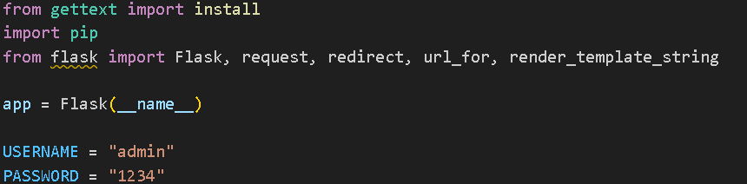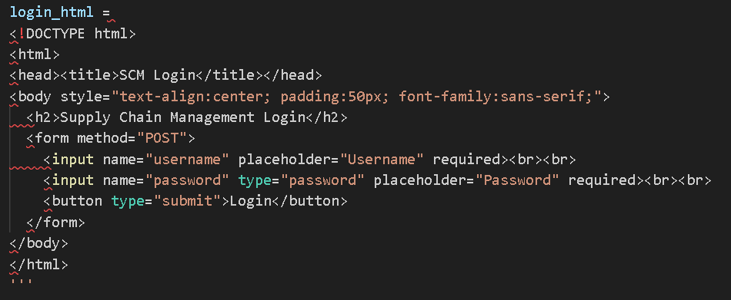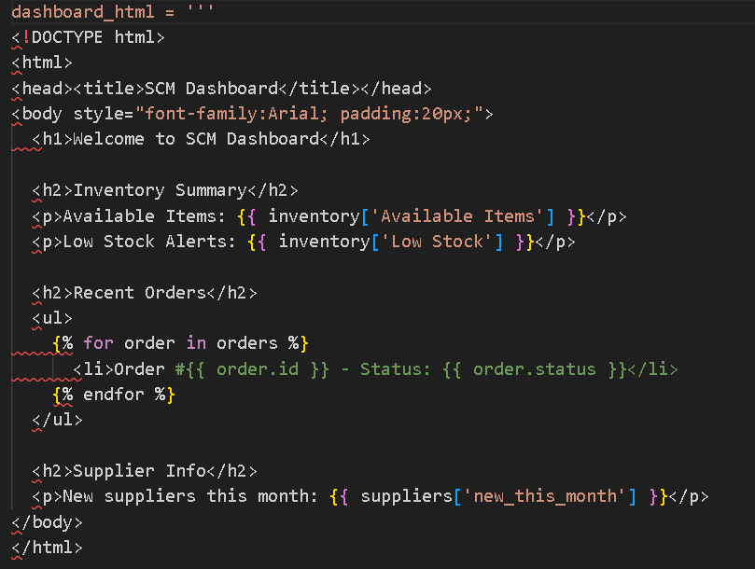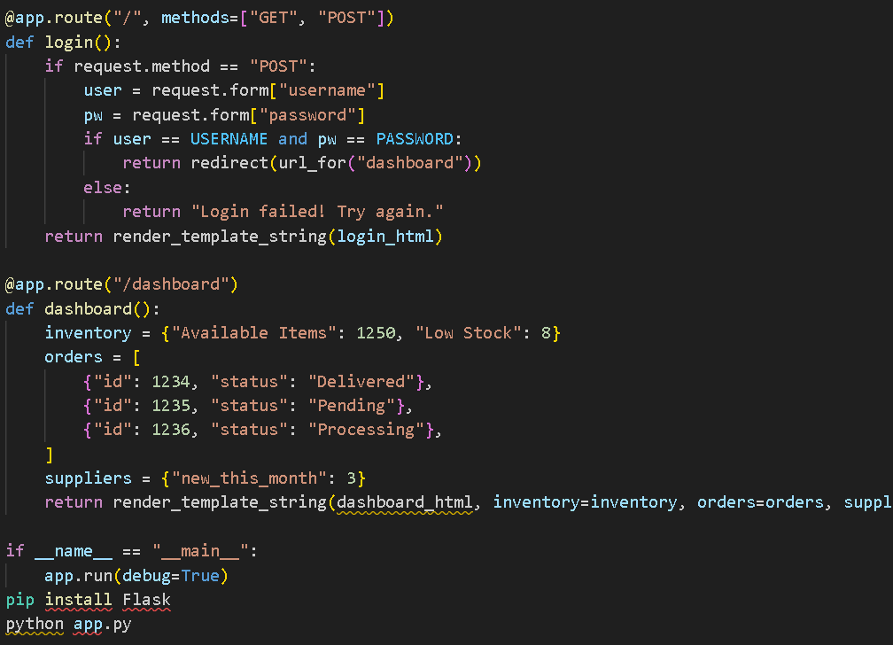--------------------------------------------------------------------------------------------------------------------------  
OUTPUT:

